Additional file 1
 | All | Asthma | COPD | Neuro-muscular Disease | Healthy/ Non-respiratory Condition
Number | 85 | 27 | 27 | 8 | 23
Age  (years) | 51.8±17.8  (18-80) | 52.6±15.9  (18-76) | 66.0±8.4  (44-80) | 41.9±19.6  (18-78) | 37.8 ± 14.6  (20-65)
Gender  (M:F%) | 42:58 | 30:70 | 37:63 | 75:25 | 52:48
BMI  (kg/m²) | 27.6±6.8  (16.7-49.2) | 27.0±6.0  (16.7-37.8) | 26.2±5.3  (18.0-38.0) | 29.0±8.6  (21.3-48.2) | 29.5±8.6  (19.5-49.2)
FEV₁  (L) | 2.02±1.04  (0.24-5.07) | 1.74±0.70  (0.93-3.38) | 1.56±0.75  (0.24-3.05) | 1.29±1.21  (0.33-3.06) | 3.13±0.90  (1.58-5.07)
FVC  (L) | 2.75±1.12  (0.38-5.66) | 2.45±0.78  (1.23-3.99) | 2.41±0.79  (0.63-3.60) | 1.69±1.69  (0.38-4.18) | 3.83±1.02  (1.89-5.66)
FEV₁/  FVC | 0.72±0.16  (0.35-0.99) | 0.71±0.16  (0.44-0.94) | 0.62±0.16  (0.35-0.85) | 0.80±0.09  (0.71-0.90) | 0.83±0.08  (0.70-0.99)

Table S1: Demographics and baseline lung function tests for patients by disease category.

Table S2: Number of patients in each disease group with a DiskusTM PIFR greater than or equal to 60 L/min and less than 60 L/min. Results from Chi-squared test are shown.The null hypothesis is that the proportions of patients with a DiskusTM PIF value less than or equal to sixty is independent of their diagnosis.As the test statistic is greater than the critical value, we can reject the null hypothesis.

PIFR (L/min) | Healthy/ Non-respiratory condition | Asthma | COPD | Neuromuscular Disease | Totals
≥ 60 | 14 | 15 | 8 | 1 | 38
<60 | 9 | 12 | 19 | 7 | 47
Totals | 23 | 27 | 27 | 8 | 85
Chi-squared Statistic= 8.04; Critical Value= 7.815; df= 3

Figure S1: Receiver Operating Characteristic Curve for spirometric PIFR versus binary DiskusTM PIFR based on threshold of 60 L/min. The solid line represents an AUC of 0.5.
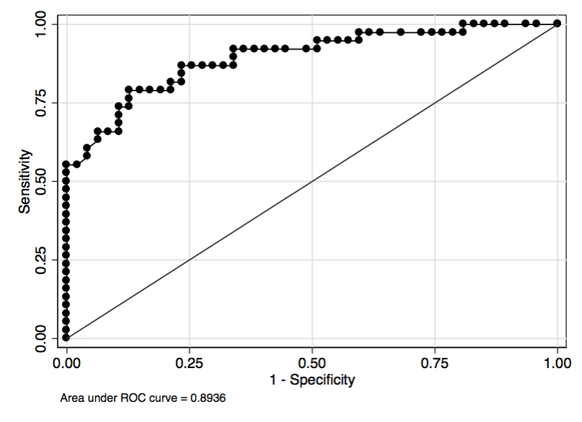
Figure S2: Receiver Operating Characteristic Curve for spirometric PIFR versus binary DiskusTM PIFR based on threshold of 30 L/min. The solid line represents an AUC of 0.5.

