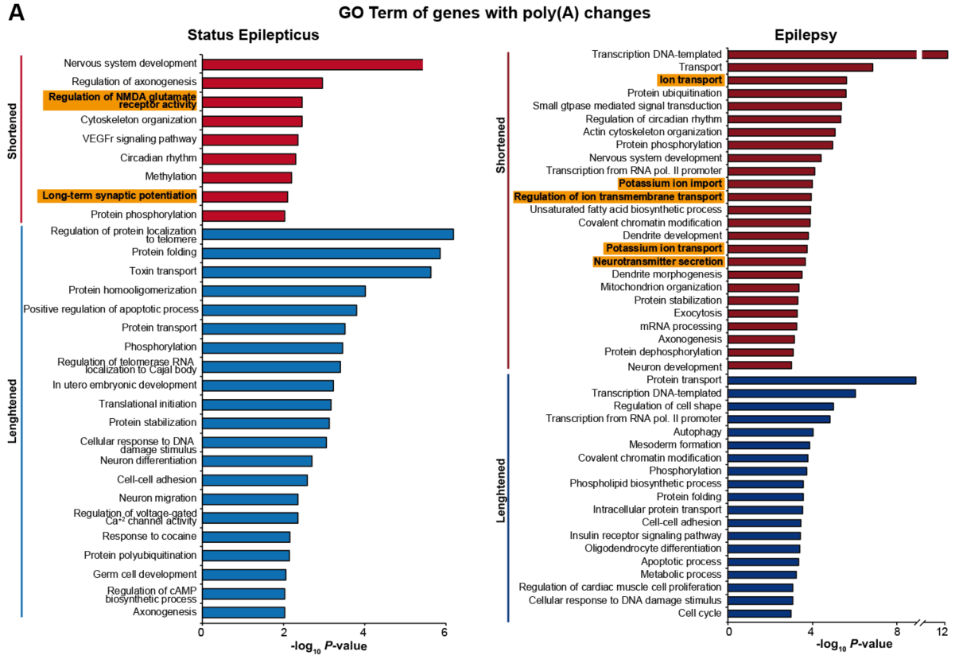
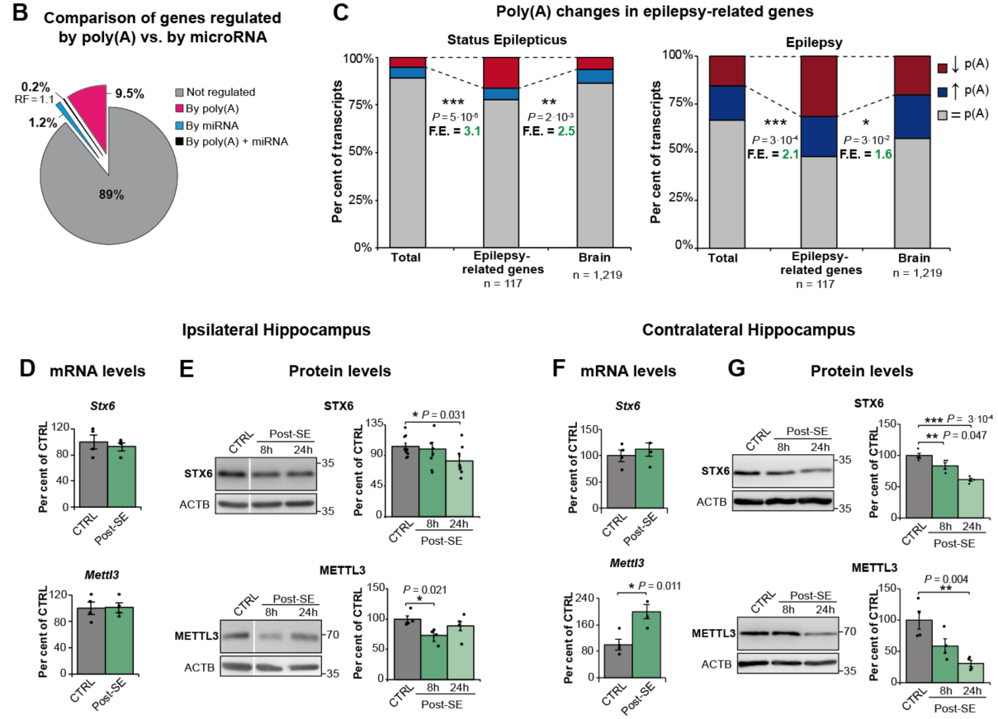

Supplementary Fig.1 Pathway analysis and polyadenylation regulated genes. (A) Top GO terms associated with biological process using DAVID resources of transcripts with poly(A) tail changes following status epilepticus and during epilepsy; the negative log10 of the P value is plotted on the X-axis. GO, Gene Ontology. (B) Percentage of transcripts with poly(A) tail length changed and/or potential genes targeted by microRNA up- and down-regulated in the ipsilateral hippocampus 8 h post-intraamygdala KA-induced status epilepticus. RF, Representation Factor. (C) Percentage of transcripts with poly(A) tail length changes following intraamygdala KA-induced status epilepticus and during epilepsy in epilepsy-related genes compared vs. total number of transcripts and brain expressed genes. F.E., fold enrichment. (D, F) mRNA levels of Stx6 and Mettl3 in the (D) ipsilateral (n = 4) and (F) contralateral (n = 4) hippocampus at 8 h post-status epilepticus, vehicle (control) vs. intraamygdala KA-treated (status epilepticus). Data were normalized to Actb. (E, G) Protein levels in the (E) ipsilateral hippocampus, METTL3 (n = 4) and STX6 (n = 8), and (G) contralateral hippocampus (n = 4) of mice injected with vehicle vs. KA at 8 h and 24 h post-status epilepticus. CTRL, control; SE, status epilepticus. Data were analyzed and normalized to the expression of ACTB. (C) One-sided Fisher’s exact test, P values of deadenylated epilepsy-related genes vs. total and brain transcriptome. (B) Hypergeometric test. (D - G) Two-sided unpaired t-test. Data are mean ± S.E.M. 95% CIs. *P < 0.05, **P < 0.01, ***P < 0.001.

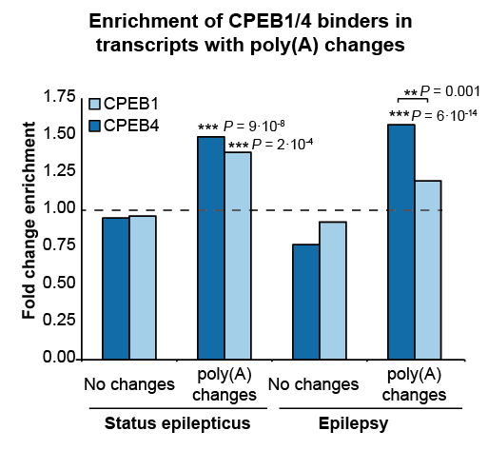
Supplementary Fig.2 Poly(A) tail changes in CPEB1/4 binders. Enrichment analysis of CPEB1- and CPEB4-only binders in transcripts with poly(A) changes post-status epilepticus and during epilepsy. One-sided Fisher’s exact test. **P < 0.01, ***P < 0.001.
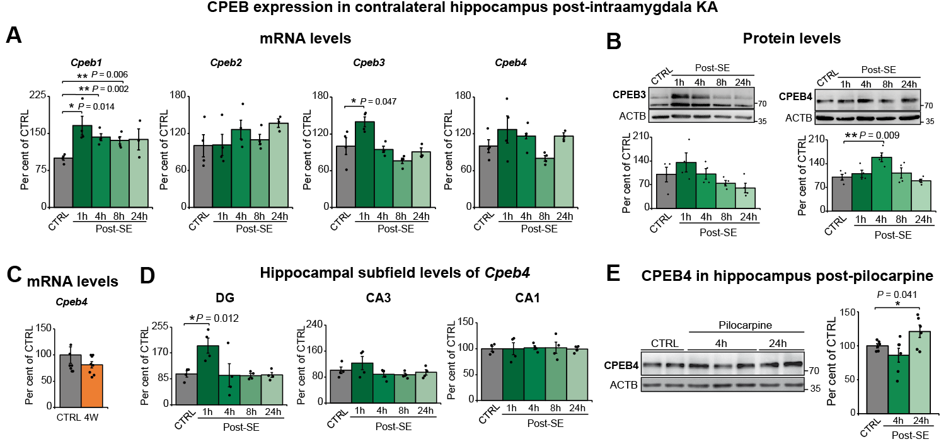Supplementary Fig.3 Additional data on CPEB expression post-status epilepticus and during epilepsy. (A) mRNA levels of Cpebs in the contralateral hippocampus of WT mice injected with vehicle (CTRL) vs. intraamygdala KA at 1 h, 4 h, 8 h and 24 h post-status epilepticus (post-SE) (n = 4). (B) Protein levels of CPEB3 and CPEB4 in contralateral hippocampus of mice subjected to intraamygdala KA-induced status epilepticus at same time-points (n = 4). (C) mRNA levels of Cpeb4 the ipsilateral hippocampus at 4 weeks after status epileptus (n = 8), and (D) in the hippocampal subfields CA1, CA3 and DG at different time points post-intraamygdala KA-induced status epilepticus (n = 4). DG, dentate gyrus. Data were analyzed and normalized to the expression of Actb. (E) CPEB4 protein levels in the hippocampus of WT mice 4 h and 24 h following intraperitoneal pilocarpine-induced status epilepticus (vehicle n = 9, pilocarpine n = 6). Protein quantity was normalized to the loading control (ACTB). (A - E) Two-sided unpaired t-test. Data are mean ± S.E.M. 95% CIs. *P < 0.05, **P < 0.01.

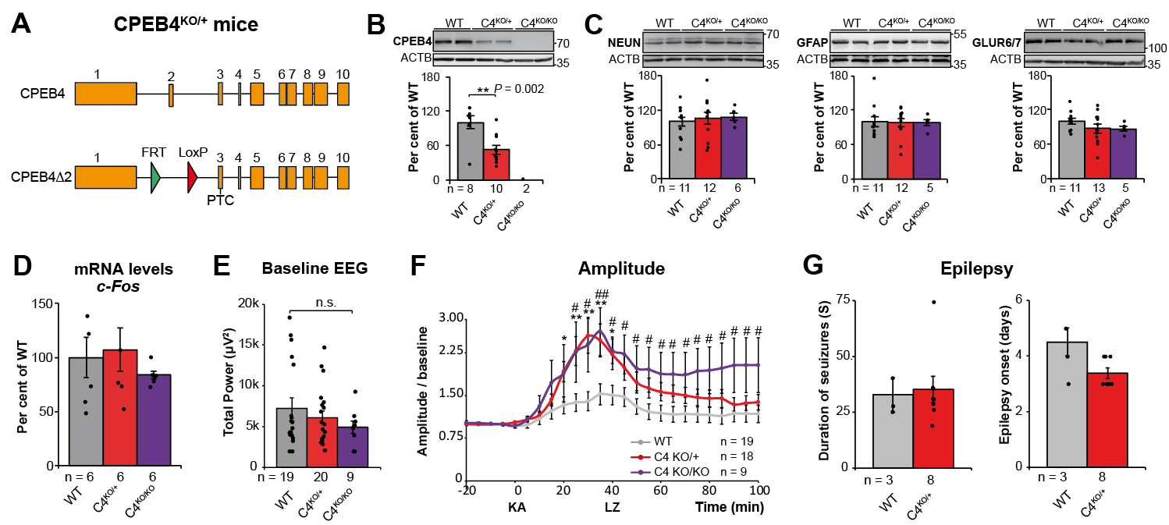

Supplementary Fig.4 Additional information on CPEB4-deficient mice. (A) Construct design. (B) CPEB4 protein levels in the hippocampus of CPEB4^{KO/+} and CPEB4^{KO/KO} mice. (C) Western blot and corresponding graphs showing NEUN, GFAP and GLUR6/7-positive protein levels in the hippocampus of WT, CPEB4^{KO/+} and CPEB4^{KO/KO} mice. Protein quantity was normalized to the loading control (ACTB). (D) c-Fos mRNA levels in the hippocampus of WT, CPEB4^{KO/+}, CPEB4^{KO/KO} mice. Data were analyzed and normalized to the expression of Actb. (E) Baseline EEG recordings of different genotypes. EEG, electroencephalogram. (F) Amplitude post-intraamygdala KA injection normalized to baseline. KA, kainic acid; LZ, lorazepam. (G) Duration and onset of spontaneous seizures in WT and CPEB4^{KO/+} mice during a 14 days after status epilepticus. Data are mean ± S.E.M. 95% CIs. WT vs CPEB4^{KO/+} *P < 0.05, **P < 0.01. WT vs CPEB4^{KO/KO} #P < 0.05, ##P < 0.01.
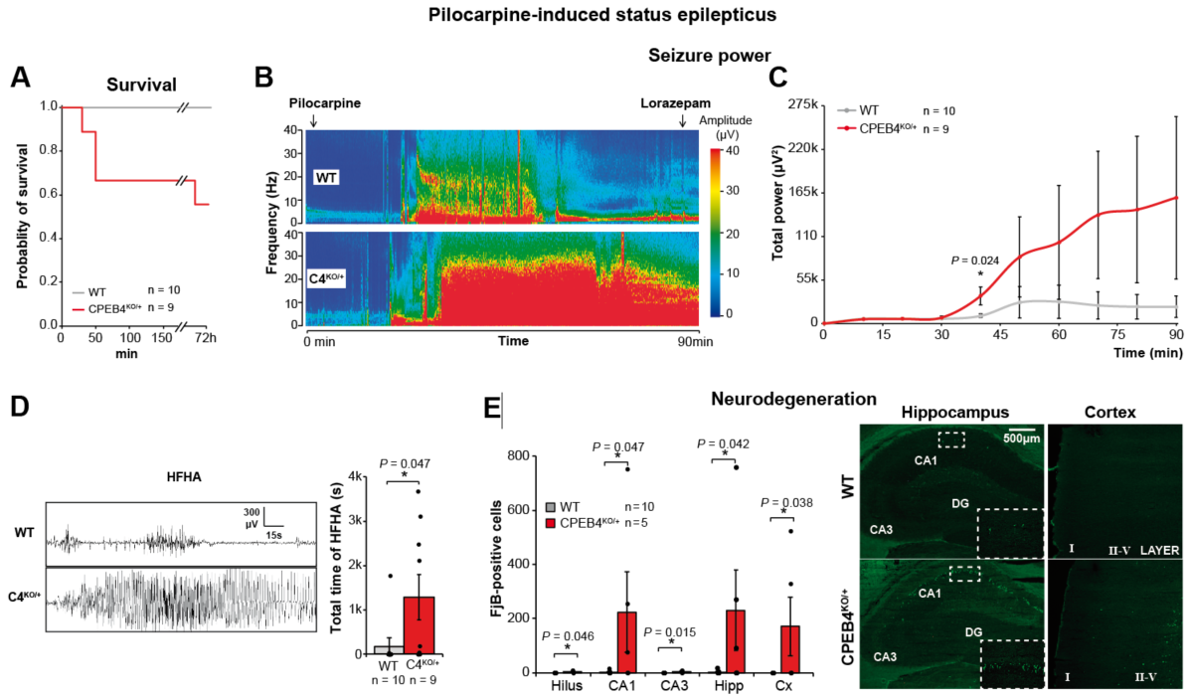
Supplementary Fig.5 CPEB4-deficiency aggravates intraperitoneal pilocarpine-induced seizures and neurodegeneration. (A) Kaplan–Meier curve for cumulative survival. (B) Representative heatmaps showing increased total seizure power in CPEB4^{KO/+} during a 90 min recording period starting at intraperitoneal pilocarpine injection. (C) Total power measured in 10 min segments. (D) Total time of high-frequency high-amplitude (HFHA) polyspike discharges and representative EEG traces. (E) Quantitative analysis of FluoroJade-B (FjB)-positive cells and representative sections of neurodegeneration in hippocampus and cortex 72h post-intraperitoneal pilocarpine induced-status epilepticus. Data are mean ± S.E.M. 95% CIs. *P < 0.05.

